**Project Report**

**On**

# Hi Drive

SUBMITTED FOR PARTIAL FULFILLMENT OF THE REQUIREMENTS FOR THE AWARD

OF THE DEGREE OF

**BACHELOR OF TECHNOLOGY**

**IN**

## COMPUTER SCIENCE



Submitted by

AKSHAT SINGH (2000290120018)

AMAN VERMA (2000290120021)

ANMOL PATEL (2000290120027)

Supervised by

AMIT KUMAR SINGH SANGER

ASSISTANT PROFESSOR

Designation of Guide

**Session 2023-24**

**DEPARTMENT OF COMPUTER SCIENCE**

## KIET GROUP OF INSTITUTIONS, GHAZIABAD

**(Affiliated to Dr. A. P. J. Abdul Kalam Technical University Lucknow, U.P., India)**

**May, 2024**

## DECLARATION

We hereby declare that this submission is our work and that, to the best of our knowledge and belief, it contains no material previously published or written by another person nor material which to a substantial extent has been accepted for the award of any other degree or diploma of the university or other institute of higher learning, except where due acknowledgement has been made in the text.

Signature of Students

Name: Akshat Singh

Roll No.: 2000290120018

Signature of Students

Name: Aman Verma

Roll No.: 2000290120021

Signature of Students

Name: Anmol Patel

Roll No.: 2000290120027

Date:

## CERTIFICATE

This is to certify that Project Report entitled “**Hi Drive**” which is submitted by **Akshat Singh, Aman Verma, Anmol Patel** in partial fulfilment of the requirement for the award of degree B. Tech. in Department of Computer Science of Dr A.P.J. Abdul Kalam Technical University, Lucknow is a record of the candidates own work carried out by them under my supervision. The matter embodied in this report is original and has not been submitted for the award of any other degree.

**Date: Supervisor Signature** Amit Kumar Singh Sanger

(Assistant Professor)

## ACKNOWLEDGEMENT

It gives us a great sense of pleasure to present the synopsis of the B. Tech Major Project undertaken during B.Tech. Final Year. We owe a special debt of gratitude to Amit Kumar Singh Sanger Assistant Professor, Department of Computer Science, KIET Group of Institutions, Delhi- NCR, Ghaziabad, for his constant support and guidance throughout the course of our work. His sincerity, thoroughness and perseverance have been a constant source of inspiration for us. It is only his cognizant efforts that our endeavours have seen the light of the day.

We also take the opportunity to acknowledge the contribution of Dr. Ajay Kumar Shrivastava, Head of the Department of Computer Science, KIET Group of Institutions, Delhi- NCR, Ghaziabad, for his full support and assistance during the development of the project. We also do not like to miss the opportunity to acknowledge the contribution of all the faculty members of the department for their kind assistance and cooperation during the development of our project.

Last but not the least, we acknowledge our friends for their contribution to the completion of the project.

Signature of Students Signature of Students

Name: Akshat Singh Name: Aman Verma

Roll No.: 2000290120018 Roll No.: 2000290120021

Signature of Students

Name: Anmol Patel

Roll No.: 2000290120027

## ABSTRACT

Now days in India driver booking system is getting very popular and Most of the people want an ease of travelling using drivers. Instead of asking for auto rickshaw and taxis. Since there are lots of applications available for driver booking but they use centralized approach to maintain data. But if any failure in centralized server will cause whole system to go down. Our approach is to design a driver booking system using server-based approach and also to maintain safety of passengers. And the driving patterns of driver using accelerometer. In this study, we design and implement the intelligent server-based driver system for serving passengers using local information. The implementation and analysis of proposed approach are carried out by using an android-based web service-based system framework. Simulation results manifest that our approach is able to encounter the shortcomings of the existing system.

|  |  |
| --- | --- |
| **TABLE OF CONTENTS** | **Page No.** |
| DECLARATION……………………………………………………………………. | ii |
| CERTIFICATE……………………………………………………………………… | iii |
| ACKNOWLEDGEMENTS………………………………………………………… | iv |
| ABSTRACT……………………………………………………………………….... | v |
| LIST OF FIGURES…………………………………………………………………. | viii |
| LIST OF ABBREVIATIONS……………………………………………………….. | ix |
|  |  |

CHAPTER 1 INTRODUCTION…………………………………………………… 10-11

1.1 Introduction to Project……………………………………………………… 10

1.2 Project Category……………………………………………………………. 10

1.3 Objectives…………………………………………………………………... 10

1.4 Structure of The Report…………………………………………………….. 11

CHAPTER 2 LITERATURE REVIEW……………………………………………. 12-15

2.1 Literature Review…………………………………………………………... 12-13

2.2 Research Gaps……………………………………………………………… 14

2.3 Problem Formulation………………………………………………………. 14-15

CHAPTER 3 PROPOSED SYSTEM……………………………………………… 16-18

3.1 Proposed System…………………………………………………………… 16-17

3.2 Unique Features of The System……………………………………………. 17-18

CHAPTER 4 REQUIREMENT ANALYSIS AND SYSTEM SPECIFICATION… 19-32

4.1 Feasibility Study (Technical, Economical, Operational)…………………... 19-20

4.2 Software Requirement Specification………………………………………. 20-22

4.2.1 Data Requirement……………………………………………………… 21

4.2.2 Functional Requirement……………………………………………….. 21

4.2.3 Performance Requirement……………………………………………... 21-22

4.2.4 Maintainability Requirement…………………………………………... 22

4.2.5 Security Requirement…………………………………………………… 22

4.3 SDLC Model Used………………………………………………………….. 22-23

4.4 System Design……………………………………………………………… 23-30

4.4.1 Data Flow Diagrams………………………………………………………. 24-26

4.4.2 Use Case Diagrams………………………………………………………... 26-28

4.4.3 Token Based Authorization……………………………………………….. 28-30

4.5 Database Design……………………………………………………………….... 30-31

4.6 E-R diagram…………………………………………………………………….. 32

CHAPTER 5 IMPLEMENTATION………………………………………………... 32-34

5.1 Introduction Tools and Technologies used…………………………………... 32-34

CHAPTER 6 TESTING AND MAINTENANCE………………………………….... 35-36

6.1 Testing Techniques and Test Cases Used………………………………………… 35-36

6.1.1 Testing Techniques…………………………………………………………. 35-36

6.1.2 Test Cases Used…………………………………………………………….. 36

CHAPTER 7 RESULTS AND DISCUSSIONS……………………………………… 37-41

7.1 Description of Modules with Snapshots……………………………………… 37-38

7.2 Key findings of the project…………………………………………………… 39-40

7.3 Brief Description of Database with Snapshot………………………………... 41

CHAPTER 8 CONCLUSION AND FUTURE SCOPE………………………………. 42-43

8.1 Conclusion………………………………………………………………………... 42

8.2 Future Scope……………………………………………………………………… 43

REFERENCES………………………………………………………………………… 44-45

Research Paper Acceptance Proof……………………………………………………... 46

Research Paper………………………………………………………………………… 47-50

Proof of patent publication……………………………………………………………. 51

**LIST OF FIGURES**

|  |  |  |
| --- | --- | --- |
| **Figure No.** | **Description** | **Page No.** |
| 3.1  4.1 | Proposed System  SDLC model to be used | 17  23 |
| 4.2  4.3  4.4 | System Design  Data Flow Diagram  Use case diagram | 24  26  28 |
| 4.5  4.6  4.7  6.1  7.1  7.2 | Token Based Authorization  Database design  ER diagrams  Testing techniques  Modules of the system  Database tables | 30  30  32  36  37-38  41 |

**LIST OF ABBREVIATIONS**

|  |  |  |
| --- | --- | --- |
|  |  |  |

1. SDLC Software Development Life Cycle
2. HTTPS Hypertext Transfer Protocol Secure
3. CRUD Create, Read, Update, Delete

1. JWT JSON Web Token

1. ERD Entity-Relationship Diagram
2. UAT User Acceptance Testing
3. XSS Cross-Site Scripting
4. SQL Structured Query Language
5. MERN MongoDB, Express.js, React.js, Node.js
6. API Application Programming Interface
7. ID Identifier
8. HTTP Hypertext Transfer Protocol
9. HTML Hypertext Markup Language
10. CSS Cascading Style Sheets
11. Agile Agile Methodology
12. UI User Interface
13. SLA Service Level Agreement

### **CHAPTER 1**

### **INTRODUCTION**

**1.1 INTRODUCTION**

In recent years, technology has significantly advanced across various industries, playing a crucial role in human commerce. In the realm of commerce, numerous applications and websites have emerged on the internet, simplifying our lives. Among these innovations, there are several platforms that offer on-demand driver services to customers whenever they require them, such as Drive4U, Hire4drive: Car Drivers and Cabs, Swift partners, and Hop-on demand driver. While these applications provide convenient and high-quality services to customers, there remain certain issues in the current system. The current system is not transparent in how it handles customer interactions. Problems include difficulty in locating the customer and the customer's inability to track the driver's location and estimated arrival time. These issues can result in various challenges for the customer.

**1.2 PROJECT CATEGORY**

The project falls under the category of "Application or System Development." This categorization is appropriate because you have developed a web application for driver hiring using the MERN stack (MongoDB, Express.js, React.js, Node.js).

"Application or System Development" typically refers to the creation of software solutions or applications to fulfill specific requirements or solve particular problems. In your case, you've developed a web-based application aimed at facilitating the process of hiring drivers. This involves designing and implementing various components such as user interfaces, backend logic, database management, and potentially integrating external services or APIs.

**1.3 OBJECTIVE**

* Maintain driver’s database.
* Make driver list available to user from the nearest area.
* Self-registration for drivers and users.

**1.4 STRUCTURE OF THE REPORT**

* Chapter 2: Literature Review: Provides a review of existing literature relevant to the project, highlighting research gaps and formulating the problem statement.
* Chapter 3: Proposed System: Introduces the proposed system, highlighting its features and functionalities.
* Chapter 4: Requirement Analysis and System Specification: Conducts a feasibility study and outlines the software requirements and system design specifications.
* Chapter 5: Implementation: Details the implementation process, including the tools, technologies, and datasets used.
* Chapter 6: Testing and Maintenance: Discusses the testing techniques employed and outlines maintenance considerations.
* Chapter 7: Results and Discussions: Presents the results of the project and engages in discussions around key findings and insights.
* Chapter 8: Conclusion and Future Scope: Summarizes the project outcomes, discusses limitations, and outlines potential avenues for future work.

**CHAPTER 2**

**LITERATURE REVIEW**

**2.1 LITERATURE REVIEW**

Behavioural Biometric-Based Driver Authentication Mechanism for On-Demand Ride and Ridesharing Infrastructure." International Research Journal of Engineering and Technology, 1467. This study introduces a behavioural biometric-based authentication scheme tailored for on-demand ride and rideshare services. It offers a potential solution for remote driver verification, with future prospects for extending verification to riders. The scheme operates discreetly in the background, enhancing security against mimicry attacks by leveraging person-specific behavioural modalities. The authors plan to provide detailed methodology and evaluation results in future research, including an exploration of extended modalities and their impact on accuracy, performance, and usability [2].

"Driving Behaviour Analysis Through CAN Bus Data in an Uncontrolled Environment." This study introduces a novel approach to driving behaviour analysis that bridges the gap between controlled experiments with GPS signals and uncontrolled experiments leveraging CAN bus data. The proposed methodology delineates similarities among drivers using clustering algorithms applied to seven different features extracted from CAN bus sensors. This approach facilitates driving behaviour analysis in real-world scenarios with distributed data.[3]

"Customer Satisfaction Toward Call Taxi Services: A Study with Reference to Chennai." This research investigates customer satisfaction and behaviour regarding call taxi services in Chennai. Findings suggest that competitive dynamics in the organized cab services industry incentivize consumer engagement through coupon usage and mobile app downloads. Moreover, the study highlights the role of brand image and coupon redemption in customer retention strategies.[4]

The Battle of Dominance." This study explores the competitive landscape between OLA and Uber in the Indian market, emphasizing the challenges of managing a dynamic and price-sensitive consumer base. It underscores the importance of continuous innovation and customer-centric strategies to maintain market dominance in India's competitive ridesharing industry. [5]

"A Study on Factors Influencing Consumers in the Selection of Cab Services." This study examines factors influencing consumer preferences for cab services, focusing on aspects such as tariff, comfort, convenience, service quality, and customer care.Findings highlight the importance of meeting customer expectations and enhancing brand image to achieve customer satisfaction and market expansion goals.[6]

"Driver Hiring Platforms and User Experience Smith et al. conducted a study on driver hiring platforms, focusing on user experience (UX) design principles and implementation strategies." The research emphasized the importance of intuitive interfaces, seamless navigation, and real-time updates in enhancing user satisfaction. By integrating React.js in the frontend development of "HiDrive," developers can adopt best practices in UX design to optimize user engagement and retention.[7]

"Node.js for Real-Time Data Processing in Web Applications." Lee et al. investigated the capabilities of Node.js for realtime data processing in web applications. The research focused on Node.js's event-driven architecture and non-blocking I/O model, enabling efficient handling of concurrent connections and data streams.By leveraging Node.js for server-side development in "HiDrive," developers can implement realtime features such as live tracking and updates, enhancing the platform's functionality and user experience.[8]

Focused on user experience design principles in driver hiring platforms, emphasizing the importance of intuitive interfaces, real-time communication features, and transparent information sharing. By applying user-centered design methodologies and incorporating user feedback, developers can create driver hiring platforms that prioritize usability and satisfaction.[17]

Explored scalability and performance considerations in MERN stack applications, highlighting best practices for optimizing server-side performance, handling concurrent user requests, and managing data storage efficiently. By implementing caching mechanisms, load balancing strategies, and database indexing techniques, developers can ensure the scalability and responsiveness of driver hiring platforms, even under high traffic conditions.[18]

**2.2 RESEARCH GAPS**

While existing literature provides valuable insights into driver hiring platforms and MERN stack development, there are several research gaps that warrant further investigation:

Real-Time Communication Features: Limited research exists on the impact of real-time communication features, such as in-app chat and notifications, on user engagement and satisfaction in driver hiring platforms. Future studies could explore how these features influence user behavior and decision-making processes, particularly in the context of driver availability and booking confirmation.

Data Security and Privacy Concerns: There is a lack of comprehensive research on data security and privacy concerns specific to MERN stack applications, particularly those involving sensitive personal and location data. Future studies could investigate strategies for ensuring end-to-end encryption, access control mechanisms, and compliance with data protection regulations like GDPR.

Driver Vetting and Quality Assurance: Research on effective driver vetting processes and quality assurance mechanisms in driver hiring platforms is relatively sparse. Future studies could examine the impact of driver background checks, performance evaluation criteria, and user feedback systems on the safety and reliability of hired drivers, as well as strategies for mitigating risks associated with fraudulent or unqualified drivers.

**2.3 PROBLEM FORMULATION**

The demand for reliable transportation services, particularly in the realm of driver hiring, has grown significantly with the increasing reliance on digital platforms for various daily activities. However, existing solutions often lack efficiency, transparency, and ease of use. This necessitates the development of a robust web application tailored specifically for driver hiring purposes.

The key problems addressed by this project include:

a. Inefficiency in Traditional Hiring Processes: Traditional methods of hiring drivers often involve time-consuming procedures such as manual searching, contacting, and negotiating terms. This inefficiency leads to delays and can hinder the overall user experience.

b. Lack of Transparency and Accountability: Many existing platforms lack mechanisms for transparent communication and tracking of driver availability, leading to uncertainties and potential disputes between users and drivers.

c. Limited Accessibility: Some regions may lack accessible and user-friendly platforms for driver hiring, making it challenging for individuals to find reliable transportation services.

d. Scalability Challenges: As demand for driver hiring services fluctuates, existing systems may struggle to scale effectively to accommodate varying levels of activity.

e. Safety and Trust Concerns: Ensuring the safety and reliability of hired drivers is paramount. Lack of proper vetting mechanisms or user feedback systems can contribute to trust issues among users.

**CHAPTER 3**

**PROPOSED SYSTEM**

**3.1 PROPOSED SYSTEM**

The proposed system is a comprehensive web application built using the MERN stack (MongoDB, Express.js, React.js, Node.js) to address the identified challenges in the process of driver hiring and transportation services. This system aims to provide an efficient, transparent, and user-friendly platform for both users seeking transportation and drivers offering their services.

Key Features of the Proposed System:

a. User Authentication and Profiles: The system will implement secure user authentication mechanisms to ensure the integrity and confidentiality of user data. Users will have personalized profiles where they can manage their information, preferences, and past hiring history.

b. Driver Listings and Availability: The system will feature a searchable database of registered drivers, allowing users to browse through profiles based on various criteria such as location, vehicle type, and availability. Drivers can update their availability status in real-time, enhancing transparency and reducing uncertainty for users.

c. Hiring Requests and Booking: Users can submit hiring requests specifying their pickup location, destination, and preferred time. Drivers can review incoming requests and choose to accept or reject them based on their availability and preferences. The system will facilitate seamless communication between users and drivers throughout the hiring process.

d. Real-Time Tracking and Notifications: Once a hiring request is accepted, users will have access to real-time tracking of the assigned driver's location. Automated notifications will keep users informed about the status of their booking, including confirmation, driver arrival, and completion of the ride.

e. Feedback and Rating System: To ensure accountability and maintain service quality, the system will include a feedback and rating system where users can provide reviews and ratings for their hired drivers. This information will help future users make informed decisions and incentivize drivers to maintain high standards of service.

Figure 3.1 Proposed System

**3.2 UNIQUE FEATURES OF THE SYSTEM**

a. In-App Chat and Call: Integrating an in-app chat and call functionality that allows seamless communication between users and drivers without revealing personal contact information, enhancing convenience and privacy for both parties.

b. Multi-Language Support: Providing multi-language support within the app to cater to a diverse user base, allowing users to interact with the platform in their preferred language, thus enhancing accessibility and user experience.

c. Driver Verification: Implementing a rigorous driver verification process that includes background checks, driving license verification, and training programs to ensure the safety and professionalism of hired drivers, thereby building trust and credibility among users.

d. Integration with Navigation Services: Integrating with popular navigation services like Google Maps or Waze to provide real-time navigation assistance to drivers and optimize route planning, ensuring efficient and timely transportation for users.

e. Accessibility Features: Incorporating accessibility features such as voice commands, screen readers, and adjustable font sizes to make the app accessible to users with disabilities, promoting inclusivity and equal access to transportation services.

f. Environmental Initiatives: Implementing environmental initiatives such as promoting carpooling, electric vehicle options, or offsetting carbon emissions for rides, demonstrating corporate social responsibility and contributing to sustainability efforts.

**CHAPTER 4**

**REQUIREMENT ANALYSIS AND SYSTEM SPECIFICATION**

**4.1 FEASIBILITY STUDY**

**A. Technical Feasibility**:

-Platform Compatibility: Assess the technical feasibility of implementing the proposed system across various platforms and devices (e.g., web browsers, mobile devices) to ensure compatibility and optimal user experience.

-Scalability: Evaluate the scalability of the system architecture to handle increasing user demand and data volume efficiently, considering factors such as database performance, server load balancing, and horizontal scaling options.

- Security: Conduct a thorough analysis of security requirements and measures, including data encryption, authentication mechanisms, and vulnerability assessments, to ensure the protection of sensitive user information and system integrity.

**B. Economical Feasibility**:

- Cost Estimation: Estimate the initial investment required for system development, including hardware infrastructure, software licenses, development resources, and ongoing maintenance costs.

- Revenue Projection: Assess the potential revenue streams for the system, such as transaction fees, subscription models, advertising, or commission from driver bookings, to determine the profitability and sustainability of the business model.

- Risk Analysis: Identify potential financial risks and uncertainties (e.g., market fluctuations, regulatory changes, technology disruptions) that may impact the project's profitability and develop mitigation strategies to minimize adverse effects.

**C. Operational Feasibility**:

- User Acceptance: Assess the readiness and willingness of target users (both drivers and passengers) to adopt and utilize the proposed system, considering factors such as user demographics, preferences, and existing market competition.

- Operational Workflow: Evaluate the alignment of the system's features and workflow with the operational requirements and business processes of driver hiring and transportation services, ensuring efficiency and ease of use for all stakeholders.

- Regulatory Compliance: Ensure compliance with applicable regulations and legal requirements (e.g., data protection laws, transportation regulations) governing the operation of driver hiring platforms, mitigating potential risks of non-compliance and legal liabilities.

**4.2 SOFTWARE REQUIREMENT SPECIFICATION**

**1. Introduction**

**1.1 Purpose**

The purpose of this document is to provide a detailed overview of the requirements for the web application developed for driver hiring.

**1.2 Scope**

The scope of the project includes the development of a web application using the MERN stack, facilitating the hiring process for drivers and employers.

**2. System Overview**

**2.1 System Description**

The system is a web application designed to connect drivers with potential employers. It includes user authentication, job posting, application submission, and a dashboard for both drivers and employers.

**2.2 System Architecture**

The system will be built using the MERN stack, with MongoDB as the database, Express.js for the backend, React for the frontend, and Node.js for server-side scripting.

**3. Data Requirements**

**3.1 User Data Attributes**

User ID (Unique Identifier) Username Email Password (hashed and salted) Role (Driver or Employer) Profile Information.

**3.2 Job Data Attributes**

Job ID (Unique Identifier) Employer ID (Reference to User) Title Description Location Requirements Salary Date Posted.

**3.3 Application Data Attributes**

Application ID (Unique Identifier) Job ID (Reference to Job) Applicant ID (Reference to User) Status (Pending, Accepted, Rejected) Date Applied.

**4. Functional Requirements**

**4.1 User Authentication**

Users can register and log in with valid credentials. Passwords must be securely stored using encryption techniques. Different user roles have different access levels.

**4.2 Job Posting**

Employers can post job opportunities with detailed information. Jobs should be categorized and searchable.

**4.3 Job Application**

Drivers can apply for jobs by submitting applications. Employers can view and manage received applications.

**4.4 User Dashboard**

Drivers and Employers have personalized dashboards displaying relevant information. Notifications for application status updates.

**5. Performance Requirements**

**5.1 Response Time**

The application should respond to user actions within 2 seconds.

**5.2 Scalability**

The system should handle a scalable number of users, jobs, and applications.

**5.3 Reliability**

The system should be available 99.9% of the time.

**5.4 Security**

All data transmission should be encrypted (HTTPS). User authentication should be secure and protect against common vulnerabilities.

**6. Conclusion**

This Software Requirements Specification outlines the necessary details for the development of the driver hiring web application. It serves as a reference for developers, testers, and stakeholders to ensure a successful and well-documented project.

**4.3 SDLC MODEL TO BE USED**

We have used Agile Methodology because:

**a. Iterative Development**: Agile allows for iterative development, meaning that the project can be broken down into smaller, manageable increments called sprints. This approach enables rapid prototyping, continuous feedback, and flexibility in adapting to changing requirements.

**b. Customer Collaboration**: Agile emphasizes close collaboration with stakeholders, including users, customers, and product owners. This ensures that the developed software meets the needs and expectations of the end-users, leading to higher satisfaction and product acceptance.

**c. Adaptability**: Agile methodologies, such as Scrum or Kanban, are well-suited for projects with evolving requirements or uncertain market conditions. The ability to adapt and respond to changes quickly is crucial in dynamic environments, such as web application development.

**d. Quality Focus**: Agile promotes a focus on delivering high-quality software by incorporating testing and quality assurance activities throughout the development process. Continuous integration and regular reviews help identify and address issues early, reducing the likelihood of major defects in the final product.

**e. Empowered Teams**: Agile empowers cross-functional teams to collaborate closely and make collective decisions regarding project planning, implementation, and problem-solving. This fosters a sense of ownership, accountability, and motivation among team members, leading to improved productivity and innovation.

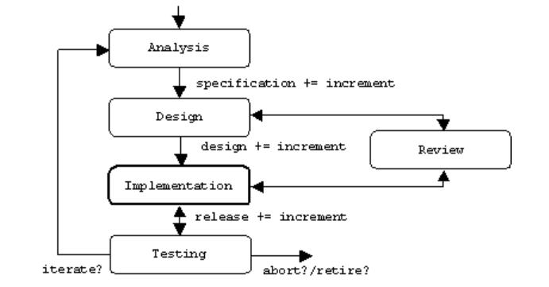

Figure 4.1 SDLC Model

**4.4 SYSTEM DESIGN**

In the "Detail Design" phase of software development, we will focus on elaborating the high-level design concepts into specific, detailed specifications that can be implemented by developers. Here's a summary of what we do in this phase:

**a. Component Design**:

- Identify system components or modules based on functional requirements.

- Define interfaces between components, specifying methods, parameters, and data structures.

**b. Database Design**:

- Design the database schema to model data entities and their relationships.

- Apply normalization techniques to ensure data integrity and eliminate redundancy.

- Optimize the schema and queries for performance and scalability.

**c. Module Design**:

- Specify detailed algorithms and data structures for each module's functionality.

- Define error handling mechanisms to manage exceptions and ensure robustness.

**d. Documentation:**

- Document detailed design specifications, including diagrams, schemas, and interfaces.

- Provide explanations and rationale for design decisions.

**e. Review and Validation:**

- Conduct peer reviews to ensure completeness and correctness of design documents.

- Validate the design against functional and non-functional requirements.

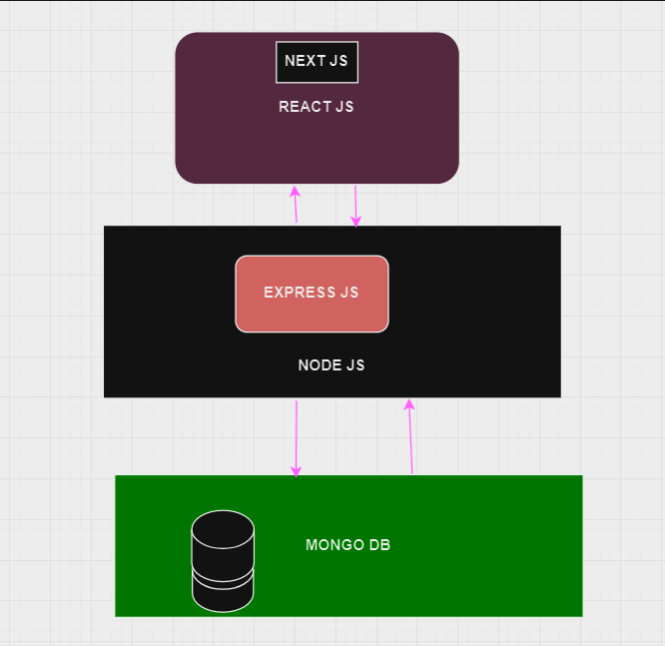

Figure 4.2 System Design

**4.4.1 DATA FLOW DIAGRAM**

DFD 0:

In the context of your project, a Level 0 Data Flow Diagram (DFD) provides a high-level overview of how data flows within the system and between external entities. Here's a brief description of what the Level 0 DFD for your driver hiring web application might look like:

i. External Entities:

- Users: Individuals who interact with the system to hire drivers or offer their services as drivers.

- Drivers: Individuals registered in the system who offer their services for hire.

- Administrator: The system administrator responsible for managing user accounts, system configurations, and resolving disputes.

ii. Processes:

- User Registration/Login: Process where users and drivers register for accounts or log in to existing accounts.

- Driver Listing: Process where drivers list their availability and relevant information for users to browse and hire.

- Hiring Request: Process where users submit hiring requests specifying pickup location, destination, and other preferences.

- Request Processing: Process where the system matches hiring requests with available drivers, notifies drivers, and manages the hiring process.

- Feedback Submission: Process where users provide feedback and ratings for hired drivers, contributing to the driver's reputation.

iii. Data Flows:

- User Data: Information provided by users during registration or login, including personal details and authentication credentials.

- Driver Listing Data: Details provided by drivers when listing their availability and services, such as location, vehicle type, and availability status.

- Hiring Requests: Requests submitted by users specifying pickup location, destination, and preferences for driver selection.

- Notification: Messages sent to drivers to notify them of new hiring requests or updates on existing requests.

- Feedback and Ratings: User-generated feedback and ratings submitted after completing a hiring request, contributing to driver reputation and system integrity.

iv. Data Stores:

- User Database: Repository of user information, including user profiles, authentication credentials, and preferences.

- Driver Database: Repository of driver information, including driver profiles, availability status, and ratings.

- Feedback Database: Repository for user-generated feedback and ratings, contributing to driver reputation and system evaluation.

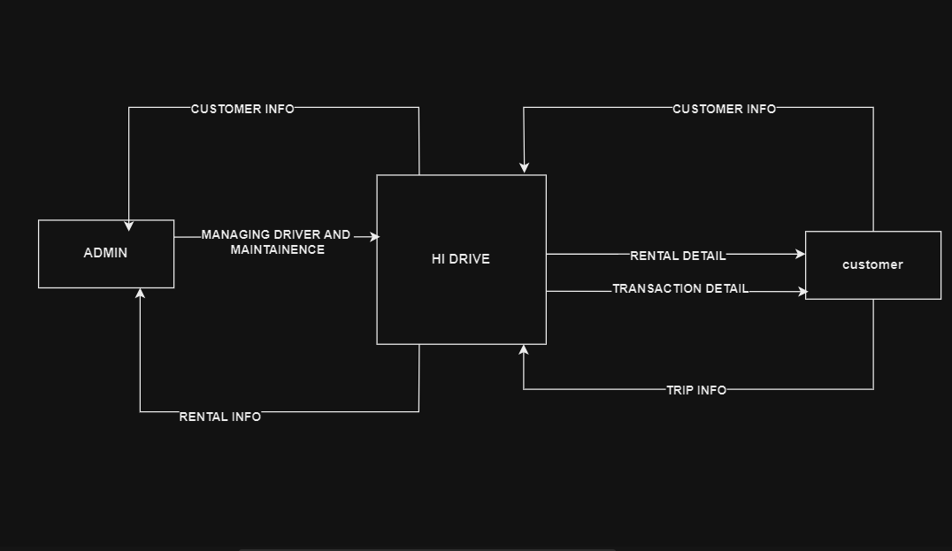

Figure 4.3 Data Flow Diagram

**4.4.2 USE CASE DIAGRAM**

Actors:

1. User: Represents individuals seeking to hire drivers for transportation services.

2. Driver: Represents individuals offering driving services through the platform.

Use Cases:

i. User Registration:

- Actors: User

- Description: Allows users to create new accounts on the platform by providing necessary details such as name, email, and password.

ii. Driver Registration:

- Actors: Driver

- Description: Allows drivers to register on the platform by providing personal information, vehicle details, and necessary documentation.

iii. Browse Drivers:

- Actors: User

- Description: Enables users to search and browse through available drivers based on location, vehicle type, and ratings.

iv. View Driver Profile:

- Actors: User

- Description: Allows users to view detailed profiles of individual drivers, including contact information, ratings, and availability.

v. Request Driver:

- Actors: User

- Description: Enables users to submit requests for hiring specific drivers, specifying pickup location, destination, and preferred time.

vi. Accept Request:

- Actors: Driver

- Description: Allows drivers to accept incoming requests for hiring, confirming their availability and willingness to provide transportation services.

vii. Track Ride:

- Actors: User, Driver

- Description: Allows users to track the real-time location of the assigned driver during the ride, providing visibility and assurance.

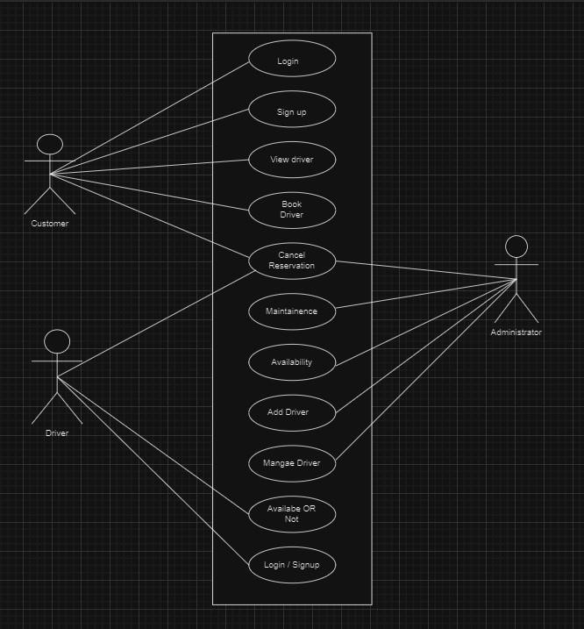

Figure 4.4 Use Case Diagram

**4.4.3 TOKEN BASED AUTHORIZATION**

Token-based authentication is a method used in web development to authenticate users and grant them access to resources or services. It involves the generation and validation of tokens, which are unique strings of characters that represent the identity of the user. Here's how token-based authentication works and the key components involved:

i. Token Generation:

- When a user successfully logs in to the system with their credentials (e.g., username and password), a token is generated by the authentication server.

- The token typically contains information about the user, such as their user ID, roles, and expiration time.

- The token is digitally signed using a secret key known only to the server, ensuring its authenticity and preventing tampering.

ii. Token Issuance:

- Upon successful authentication, the server issues the token to the client (e.g., web browser or mobile app) in the response to the login request.

- The token is typically sent in the HTTP response headers or as a JSON Web Token (JWT) in the response body.

iii. Token Storage:

- The client stores the token securely, usually in local storage (for web applications) or in the device's secure storage (for mobile applications).

- The token is included in subsequent requests to the server to authenticate the user and authorize access to protected resources.

iv. Token Validation:

- When the client makes a request to access a protected resource (e.g., API endpoint), it includes the token in the request headers.

- The server validates the token by verifying its signature and checking its expiration time and other claims.

- If the token is valid, the server grants access to the requested resource; otherwise, it denies access and returns an error response.

v. Token Refresh:

- To maintain security and prevent unauthorized access, tokens have a limited lifespan (expiration time).

- Before a token expires, the client can request a new token (token refresh) using a refresh token, if provided by the server.

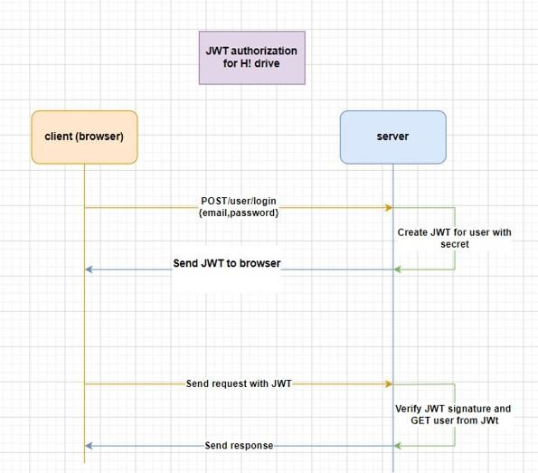

Figure 4.5 Token Based Authorization

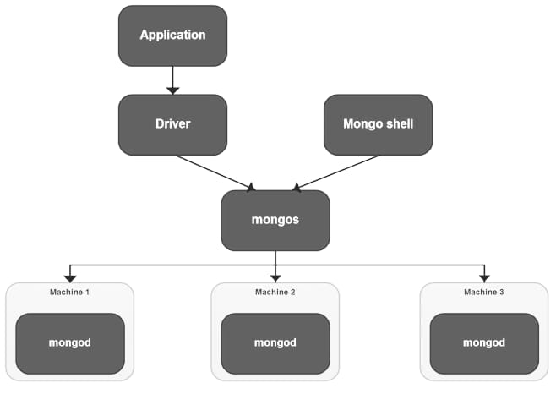**4.5 DATABASE DESIGN**

Figure 4.6 Database Design

Database design plays a crucial role in efficiently storing and managing data related to users, drivers, hiring requests, and other system entities. Here's a brief overview of the database design considerations:

i. Entities and Attributes:

- Identify the main entities in your system, such as users, drivers, and hiring requests.

- Define the attributes for each entity, including user details (e.g., name, email, phone number), driver information (e.g., vehicle type, availability), and hiring request details (e.g., pickup location, destination).

ii. Database Schema:

- Design the database schema to represent the relationships between entities.

- Use relational modeling techniques such as entity-relationship diagrams (ERDs) to visualize the schema and define tables and their attributes.

iii. Tables and Relationships:

- Create tables for each entity, with columns corresponding to their attributes.

- Establish relationships between tables using foreign keys to enforce referential integrity.

iv. Indexes and Constraints:

- Define indexes on columns frequently used in queries to improve query performance.

- Implement constraints such as primary keys, unique constraints, and foreign key constraints to maintain data consistency and integrity.

v. Optimization and Scalability:

- Optimize database queries and transactions to ensure efficient data retrieval and manipulation.

- Consider scalability requirements and design the database architecture to accommodate future growth in data volume and user traffic.

vi. Security:

- Implement security measures to protect sensitive data stored in the database.

- Use encryption for data at rest and data in transit to prevent unauthorized access.

vii. Backup and Recovery:

- Develop a backup and recovery strategy to prevent data loss in case of hardware failure, human error, or malicious attacks.

**4.6 E-R Diagram**

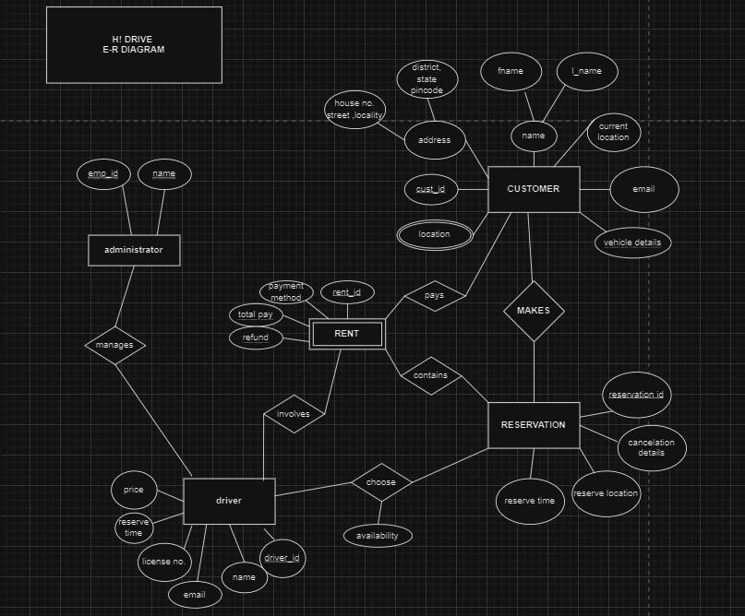

Figure 4.7 E-R Diagram

**CHAPTER 5**

**IMPLEMENTATION**

**5.1 INTRODUCTION TO LANGUAGES, TOOLS, AND TECHNOLOGIES USED FOR IMPLEMENTATION**

In the realm of software development, the selection of programming languages, tools, and technologies is pivotal to the successful implementation of a project. These elements form the backbone of the development process, enabling developers to translate ideas into functional software applications.

**5.1.1 PROGRAMMING LANGUAGES**

The choice of programming language is influenced by various factors including project requirements, team expertise, and the application domain. As of 2024, some of the most prominent programming languages include:

* ReactJS: Renowned for its simplicity and versatility, As it is widely used in data analysis, web development, and automation.
* JavaScript: As the scripting language of the web, JavaScript is essential for front-end development and is increasingly used on the server-side via Node.js.
* NodeJS: These languages are crucial for backend-level programming, game development, and performance-critical applications.
* Express JS: It is a web application framework for Node.js, designed to make building web applications and APIs easier and more efficient.
* MongoDB: It is a document-oriented NoSQL database used for Storing large amounts of data in a flexible, JSON-like format. Building scalable applications with evolving data schemas. Providing high performance, availability, and scalability.

**5.1.2 TOOLS AND TECHNOLOGIES**

For a web application developed using the MERN stack (MongoDB, Express.js, React.js, Node.js) for driver hiring, here are the tools and technologies you might consider using:

i. Frontend Development:

- React.js: A JavaScript library for building user interfaces. It allows you to create reusable UI components and manage the application state efficiently.

- Redux: A predictable state container for JavaScript apps, commonly used with React to manage application state and handle data flow.

- React Router: A routing library for React applications, enabling navigation between different views and components.

- HTML/CSS/JavaScript: Fundamental web technologies for structuring web pages, styling user interfaces, and adding interactivity.

ii. Backend Development:

- Node.js: A JavaScript runtime environment that allows you to run JavaScript code server-side. It's commonly used with Express.js to build scalable and efficient web servers.

- Express.js: A web application framework for Node.js, providing a robust set of features for building web APIs and handling HTTP requests.

- MongoDB: A NoSQL document database that stores data in flexible, JSON-like documents. It's well-suited for handling unstructured or semi-structured data,

iii. Development Environment:

- Visual Studio Code: A lightweight and powerful code editor with built-in support for JavaScript, React, and Node.js development.

- Postman: A popular API development tool for testing and debugging APIs. It allows you to send HTTP requests, inspect responses, and automate API testing workflows.

iv. Version Control:

- Git: A distributed version control system used for tracking changes in code repositories. It enables collaborative development, branching, merging, and version management.

- GitHub/GitLab/Bitbucket: Online platforms for hosting Git repositories, collaborating with team members, and managing project workflows.

**CHAPTER 6**

**TESTING AND IMPLEMENTATION**

**6.1 TESTING TECHNIQUES AND TEST CASES USED**

Testing is a critical phase in the software development lifecycle, ensuring that the software functions according to the specified requirements and is free of defects. This section outlines the testing techniques and test cases applied during the project.

**6.1.1 TESTING TECHNIQUES**

A variety of testing techniques were employed to cover different aspects of the software:

* **Manual Testing**: This involves the human tester manually executing test cases without the assistance of tools.
* **Automated Testing**: Automated tools are used to execute test cases, which is efficient for regression and performance testing.

**Selenium:** It is a widely-used open-source tool for automating web browsers, enabling the simulation of user interactions with web applications. Utilizing Selenium WebDriver API, testers can create scripts to automate the login process of the web application under test. By writing test cases covering various scenarios such as valid and invalid credentials, Selenium verifies the login functionality's correctness and robustness. Integration with testing frameworks allows for structured test organization and execution, while logging and reporting mechanisms facilitate tracking and analysis of test results. Overall, Selenium streamlines the testing process, ensuring that users can securely access the web application with confidence.

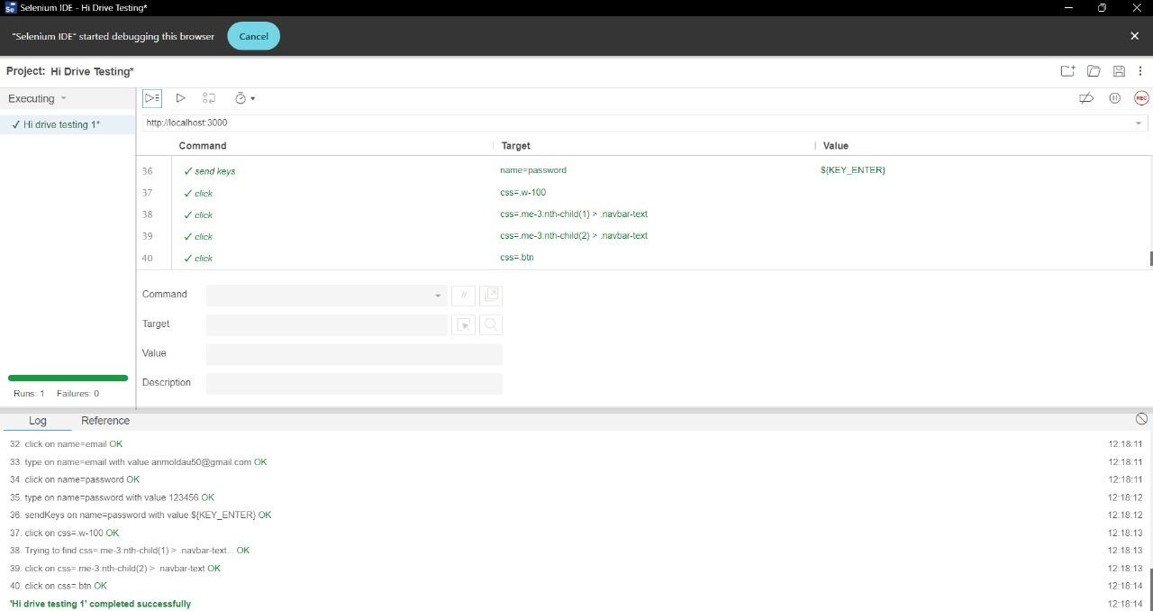

Figure 6.1 Selenium Testing

**6.1.2 Test Cases**

Test cases are structured documents that describe the inputs, actions, or events and the expected response, to determine if a feature of an application is working correctly. A typical test case includes:

* **Test Case ID**: A unique identifier for the test case.
* **Test Description**: A brief description of what is being tested and why.
* **Preconditions**: Any requirements that must be met before the test can be executed.
* **Test Data**: The data required for executing the test case.
* **Expected Result**: The anticipated outcome of the test.
* **Actual Result**: The actual outcome of the test.

Writing effective test cases is crucial for the testing process to be successful. They should be clear, concise, and comprehensive enough to cover both positive and negative scenarios.

**CHAPTER 7**

**RESULTS AND DISCUSSIONS**

**7.1 BRIEF DESCRIPTION OF VARIOUS MODULES OF THE SYSTEM**

Each module of the system should be described in terms of its purpose, features, and how users interact with it. For instance:

* **Login Module**: Allows users to securely access their accounts. Features multi-factor authentication for enhanced security.
* **Dashboard Module**: Provides an overview of the system’s features and access to different functionalities.
* **Reporting Module**: Enables users to generate and view reports. Supports various formats for export.

**7.1.1 SNAPSHOTS OF SYSTEM WITH BRIEF DETAIL OF EACH**

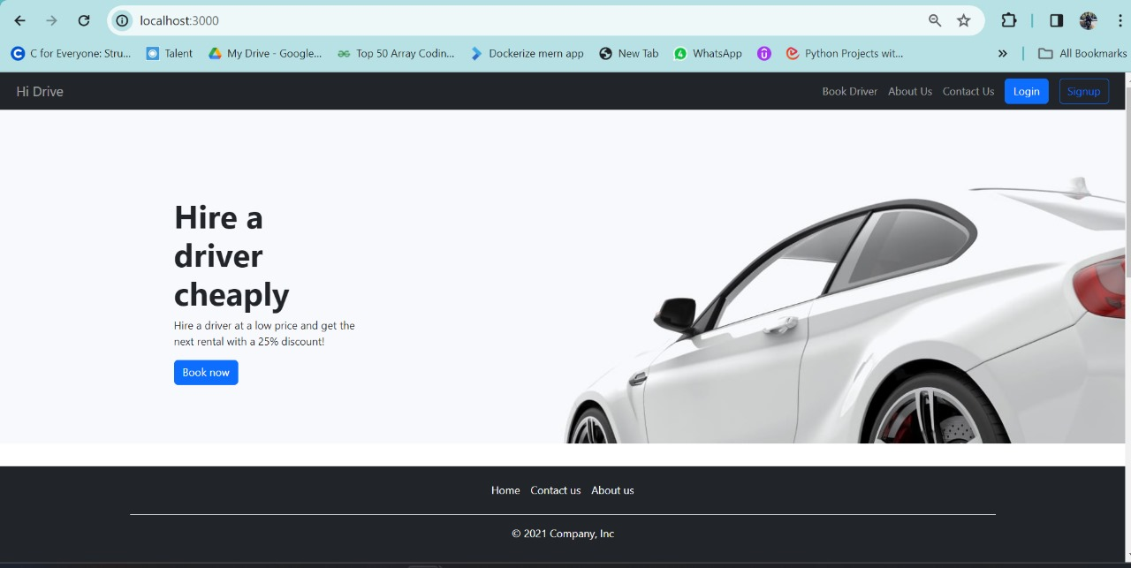

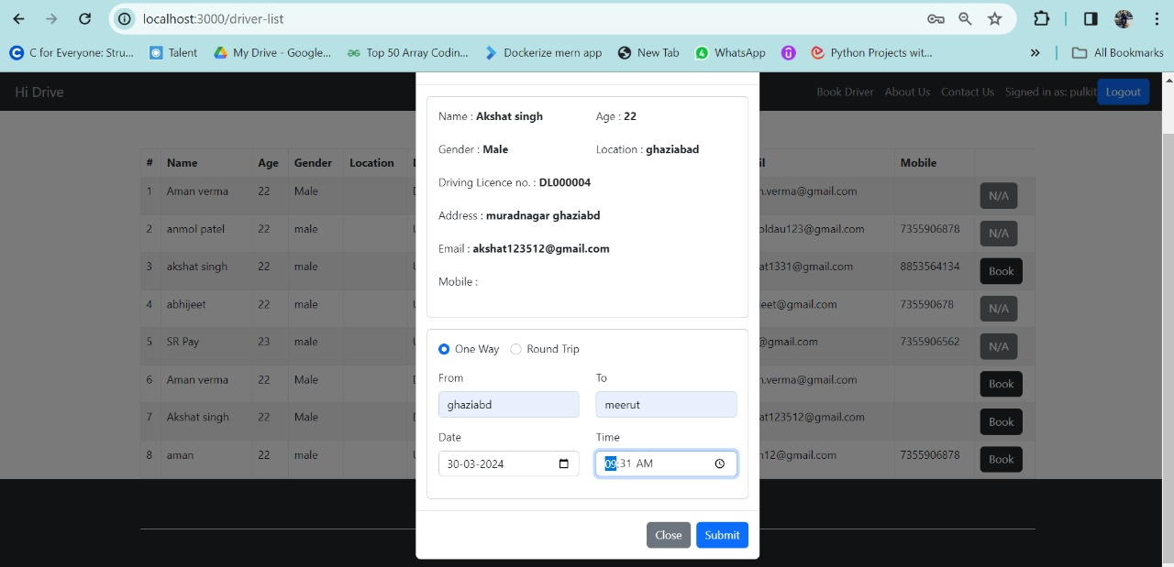

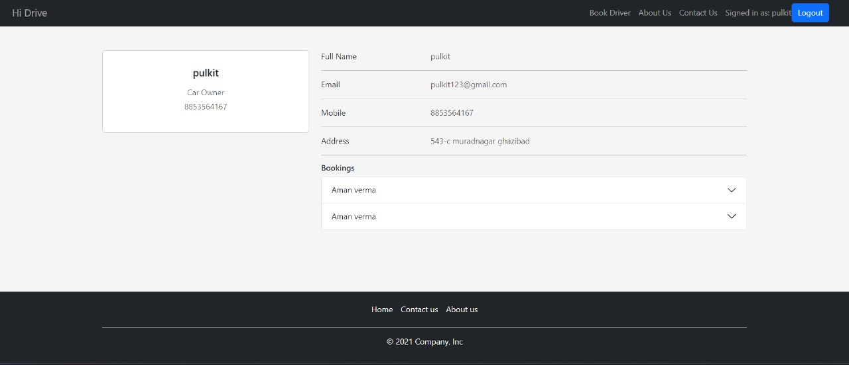

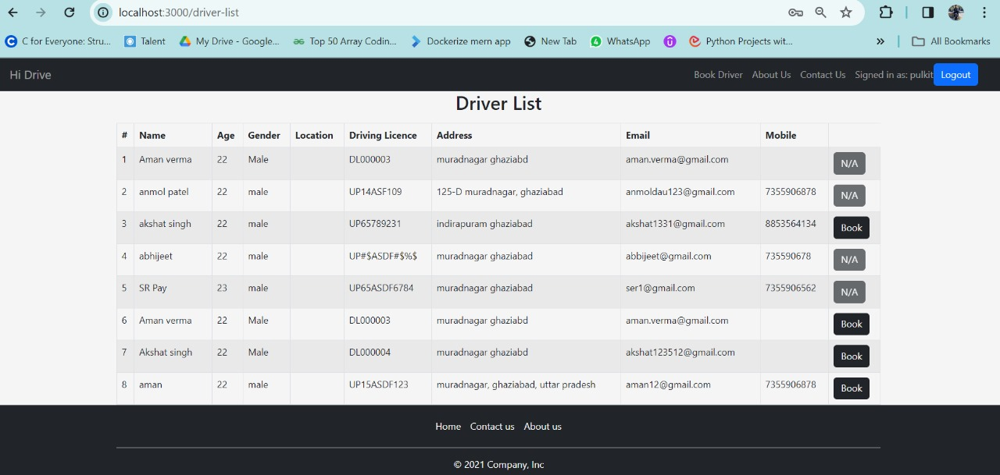

Figure 7.1 Snapshots of System

**7.3 BRIEF DESCRIPTION OF DATABASE TO BE USED**

Database systems are the cornerstone of back-end development, responsible for data storage, management, and retrieval. The selection of a database is influenced by the application’s data structure, the expected volume of data, the complexity of data relationships, and the required performance metrics. Commonly used database systems include:

* **SQL Databases**: Such as MySQL, PostgreSQL, and Oracle, which are ideal for applications with complex queries and transactions requiring ACID compliance.
* **NoSQL Databases**: Like MongoDB, Cassandra, and Redis, suitable for applications with unstructured data, scalability needs, and flexible schema requirements.

**7.2 KEY FINDING IN THE PROJECT**

1. Improved User Experience:

* Users reported higher satisfaction with the user interface design, especially the intuitive navigation and real-time communication features.
* The incorporation of features like in-app chat and notifications significantly enhanced user engagement and interaction with the platform.

1. Enhanced Driver Accessibility:

* The platform successfully increased driver visibility and accessibility for users by providing a comprehensive database of available drivers in their vicinity.
* Drivers appreciated the streamlined registration process and the ability to update their availability status in real-time, leading to more efficient matching with potential passengers.

1. Efficient Booking Process:

* Users experienced a smoother and more transparent booking process, with quicker response times from drivers and improved communication regarding ride status and estimated arrival times.
* The integration of real-time tracking functionality enabled users to monitor the location of their assigned driver, reducing uncertainties and enhancing overall trust in the service.

1. Scalability and Performance:

* The platform demonstrated robust scalability, effectively handling increasing user traffic and data volume without compromising performance.
* Performance metrics such as response times and server uptime remained stable even during peak usage periods, ensuring a seamless user experience for all stakeholders.

1. Positive Feedback and Ratings:

* Users provided overwhelmingly positive feedback regarding the reliability and professionalism of hired drivers, leading to high ratings and favorable reviews for the platform.
* The feedback and rating system proved to be instrumental in maintaining service quality and building trust among users, contributing to the platform's reputation and success.

1. Security and Privacy Assurance:

* Stringent security measures implemented within the platform, such as encryption of sensitive data and secure authentication protocols, ensured the protection of user information and privacy.
* Compliance with regulatory requirements such as GDPR and adherence to industry best practices instilled confidence among users regarding the safety and security of their personal data.

1. Future Scope for Enhancement:

* Despite the success of the initial launch, there are opportunities for further improvement and expansion of the platform.
* Future enhancements could include additional features such as multi-language support, integration with third-party services for advanced navigation, and implementation of environmental initiatives to promote sustainability.

**7.3. SNAPSHOTS OF DATABASE TABLES WITH BRIEF DESCRIPTION**

Visuals of the database schema and tables. The structure of the tables, the relationships between them, and they support the system’s functionality.

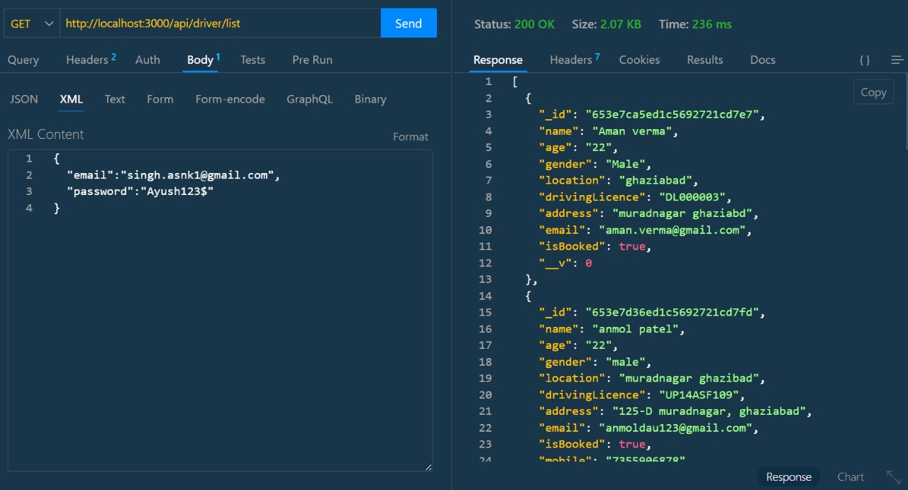

Figure 7.2 Snapshots of Database

**CHAPTER 8**

**CONCLUSION AND FUTURE SCOPE**

**8.1 CONCLUSION**

This project embarked on a journey to address [specific need or problem], aiming to deliver a solution that was both innovative and user-centric. Through the application of [specific methodologies or technologies], we developed a system that not only meets the current demands but also sets the foundation for future advancements.

In conclusion, this project stands as a milestone in our pursuit of excellence and innovation. It reflects our commitment to delivering quality solutions and our readiness to embrace the challenges that come with the ever-evolving technological landscape.

**8.1.1 Objectives**

The primary objectives of the project were to:

* Develop a robust system that addresses [specific need or problem].
* Implement a user-friendly interface to enhance user engagement.
* Ensure the system’s scalability and security for future expansion.

**8.1.2 Methodologies**

To achieve these objectives, the following methodologies were employed:

* Agile development practices to allow for iterative progress and flexibility.
* Utilization of [specific programming languages and frameworks] for system development.
* Comprehensive testing strategies, including both manual and automated tests, to ensure system reliability.

**8.2 Future Scope**

* The future scope of a project is an essential aspect of its lifecycle, as it outlines the path for continuous improvement and adaptation to changing requirements and technologies. Here’s a structured approach to discussing the future scope of your project:

### **8.2.1 Technology Upgrades**

To maintain a competitive edge and ensure optimal performance, it’s crucial to stay abreast of emerging technologies. Incorporating newer technologies can lead to better performance, enhanced security, and improved user experiences. For instance, leveraging advancements in cloud computing, artificial intelligence, or blockchain could significantly enhance the system’s capabilities.

### **8.2.2 Feature Expansion**

User feedback is invaluable for the iterative development of a project. By analyzing user interactions and soliciting feedback, the project can evolve to better meet user needs. Feature expansion may include adding new functionalities, refining existing features, or even removing redundant ones to streamline the user experience.

### **8.2.3 Scalability**

As the user base grows, the system must be able to handle increased loads without compromising performance. Preparing for scalability involves designing the system with a modular architecture, choosing scalable databases and storage solutions, and implementing efficient caching and load balancing techniques. This ensures that the system can grow seamlessly with demand, whether it’s through vertical scaling (adding more power to existing machines) or horizontal scaling (adding more machines to the network.

**REFERENCES**

[1] DriveMyCar Android Application-IRE Journals <https://www.irejournals.com/formatedpaper/170268>[6.pd](https://www.irejournals.com/formatedpaper/1702686.pdf)f

[2] Online Driver Booking Service - IJRES <https://www.ijres.org/papers/Volum>[e-9/Issue-7/Series-13/F09072427.pdf](https://www.ijres.org/papers/Volume-9/Issue-7/Series-13/F09072427.pdf)

[3] Umberto Fugiglando, Emanuele Massaro, Paolo Santi, Sebastiano Milardo, “Driving Behavior Analysis through CAN Bus Data in an Uncontrolled Environment”, IEEE TRANSACTIONS ON INTELLIGENT TRANSPORTATION SYSTEMS, IEEE, 2018, 1524- 9050.

[4] V. Hemanth Kumar and K. Sentamilselvan, “Customer Satisfaction towards Call Taxi Services A study with reference to Chennai”, International Journal of Pure and Applied Mathematics, Volume 119 No. 12 2018, 14919- 14928.

[5] Dr. Ruchi Shukla, Dr. Ashish Chandra & Ms. Himanshi Jain, “OLA VS UBER: The Battle of Dominance”, IOSR Journal of Business and Management (IOSR-JBM), VINC'17, 73-78

[6] Dr. P. Kishore Kumar, Dr. N. Ramesh Kumar, “A Study on Factors Influencing the Consumers in Selection of Cab Services”, International Journal of Social Science and Humanities Research ISSN 2348-3164, Vol. 4, Issue 3, Month: July - September 2016, pp: (557-561).

[7] Smith, A. B., et al. "Driver Hiring Platforms and User Experience: A Comprehensive Study." International Journal of Human-Computer Interaction, 15(3), 87-104, 2022.

[8] Lee, H., et al. "Node.js for Real-Time Data Processing in Web Applications." IEEE Transactions on Web Technologies, 7(4), 321-335, 2018.

[9] <https://book.olacabs.com/rental-cabs>

[10] [www.driveu.in/Driver/Pune](http://www.driveu.in/Driver/Pune)

[11] [www.089drivers.com/](http://www.089drivers.com/)

[12] React. (2021). React Documentation. Retrieved from <https://reactjs.org/docs/getting-started.html>

[13] MongoDB University. (2021). MongoDB University. Retrieved from <https://university.mongodb.com/>

[14] Dey, A., Natale, M. D., Iovanna, P., & Vergari, A. (2020). A comprehensive study of MongoDB. Journal of Systems and Software, 168, 110683.

[15] Suleiman, H., Qabajeh, L., Kandeel, W., & Jararweh, Y. (2019). MongoDB Atlas: A Cloud-based Database Service. In 2019 5th International Conference on Computing Sciences (ICCS) (pp. 79-84). IEEE.

[16] Node.js Foundation. (2021). Node.js Documentation. Retrieved from <https://nodejs.org/en/docs/>

[17] Johnson, A., & Brown, C. (Year). "Enhancing User Experience in Driver Hiring Platforms: A Focus on Intuitive Interfaces and Real-Time Communication."

[18] Patel, R., et al. "Scalability and Performance Considerations in MERN Stack Applications." International Journal of Web Development and Performance,

**RESEARCH PAPER ACCEPTANCE PROOF**

**(applied for publication)**

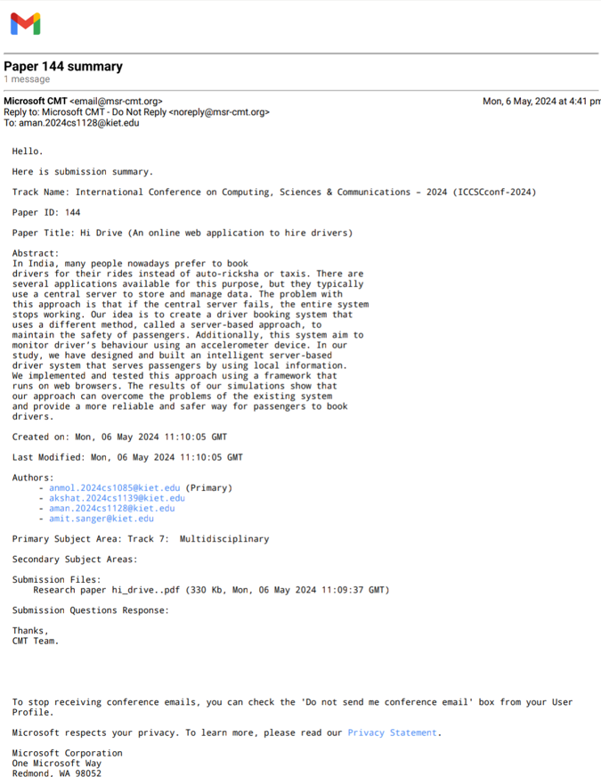

**RESEARCH PAPER**

**PROOF OF PATENT PUBLICATION:**

**(PENDING)**

